
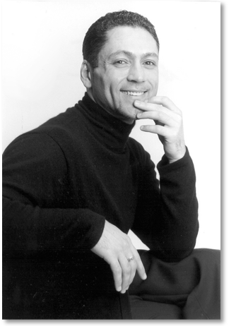
Jose Maria Condemi’s directorial work, which has been presented by companies in North America and abroad, encompasses an eclectic range of styles and repertoire and has been consistently praised for its creatively theatrical and innovative approach.
Notable engagements include Carmen, Madama Butterfly, Faust, Tosca, Così fan tutte, Un Ballo in Maschera, The Elixir of Love for Families and the world premiere of The Secret Garden (San Francisco Opera), Ernani, Tristan und Isolde and Il Barbiere di Siviglia for Families (Lyric Opera Chicago), Aida (Houston Grand Opera), Luisa Miller (Canadian Opera Company), Orphee et Eurydice, La Bohème, Tosca and Il Trovatore (Seattle Opera), Frida (Michigan Opera Theater), Tosca, Ainadamar, Don Giovanni, La Traviata, Il Trovatore and Maria de Buenos Aires (Cincinnati Opera), A Streetcar Named Desire (Kentucky Opera), Don Giovanni (Portland Opera), Cosi fan tutte and Il Barbiere di Siviglia (Atlanta Opera), Cendrillon (New Orleans Opera), The Elixir of Love (Opera Theatre of Saint Louis), Maria Padilla (Minnesota Opera), Florencia en el Amazonas (Opera Colorado and Utah Opera), Simone Boccanegra (Teatro Colon/Buenos Aires), Il Trovatore (Austin Lyric Opera), Tosca and Maria de Buenos Aires (Florida Grand Opera), La Traviata (Wolftrap Opera), Carmen (Lyric Opera of Kansas City), Falstaff, Die Zauberflöte, L'elisir d'amore, La Rondine, Don Pasquale and La Traviata (Opera San Jose), Susannah and Roméo and Juliette (Festival Opera) and the San Francisco Opera Western Opera Theater's national tours of Die Fledermaus and Don Giovanni. As Associate Director, he has worked on The Ring Cycle and Les Troyens (San Francisco Opera), Così Fan Tutte (Lyric Opera Chicago) Ballo in Maschera (Canadian Opera Company) and Falstaff (Houston Grand Opera.) Collaborations with contemporary composers include directing the world premieres of Hector Armienta's River of Women and The Weeping Woman and the workshop performance of the San Francisco Opera commissioned piece Earthrise by 2000 Pulitzer Prize Lewis Spratlan.
His theater directing credits include Caryl Churchill's Mad Forest, Dürrenmatt's The Physicists, Dorfman's Death and the Maiden and Lorca's The House of Bernarda Alba.
Mr. Condemi is also in high demand as a trainer of young artists and has been a guest lecturer, master teacher and stage director for the San Francisco Opera Center, Seattle Opera Young Artists Program, San Francisco Conservatory of Music, Houston Grand Opera Studio, Indiana University, University of Cincinnati/CCM, University of Houston Moores School, Opera Theater of Lucca and the New National Theater Young Artists Programme in Tokyo. Highlights of his educational directing assignments include new productions of Suor Angelica, Gianni Schicchi, La Bohème, La Cenerentola and A Streetcar Named Desire for the Merola Opera Program, Così fan Tutte for the Seattle Opera Young Artist Program and Dead Man Walking for Indiana University.
Originally from Argentina, Mr. Condemi received an undergraduate degree in Opera Stage Direction at the Teatro Colón/Buenos Aires and completed a Master of Fine Arts in Directing at the University of Cincinnati College-Conservatory of Music. He was also a first-time Adler Fellow in Stage Direction at the San Francisco Opera and a Fulbright Fellow
Upcoming directing engagements include new productions of Le Portrait de Manon and Suor Angelica (San Francisco Conservatory of Music), Frida (Cincinnati Opera), Carmen (Central City Opera), Tosca (L’Opera de Montreal) as well as return engagements with Indiana University and Michigan Opera Theater.
Condemi is the Carol Franc Buck Distinguished Chair and the Director of Opera and Musical Theater at the San Francisco Conservatory of Music. He was also the Artistic Director of Opera Santa Barbara from 2010 until 2015 where he oversaw artistic planning and the Studio Artists Program.

Visual portfolio, review excerpts and calendar at www.josemariacondemi.com

Barrett Artists Phone: 212-245-3530 www.barrettartists.com

